Experiment: 7
Analog Beamforming Analysis Using MATLAB
Aim
To analyze the performance of analog beamforming by studying beamforming gain, beam width, and main lobe direction using MATLAB.
Objectives
1. To analyze the beamforming gain achieved by varying the number of antenna elements in an analog beamforming system using MATLAB.
2. To compare the beam width of an antenna array for different beamforming configurations using MATLAB.
3. To analyze the main lobe direction by steering the antenna array beam to different angles using MATLAB.
Software Required
• MATLAB

Objective – 1
Analyze Beamforming Gain (dB)
Generate beamforming gain values for different antenna array sizes using MATLAB. Compare how increasing the number of antenna elements improves the beamforming gain and enhances signal strength.

MATLAB Code:
clc;
clear;
close all;
antennas = [2 4 8 16 32]; % Number of Antenna Elements
gain = 10*log10(antennas); % Beamforming Gain (dB)
figure
bar(antennas, gain)
grid onxlabel('Number of Antenna Elements')
ylabel('Beamforming Gain (dB)')
title('Beamforming Gain for Different Antenna Array Sizes')

Expected Output
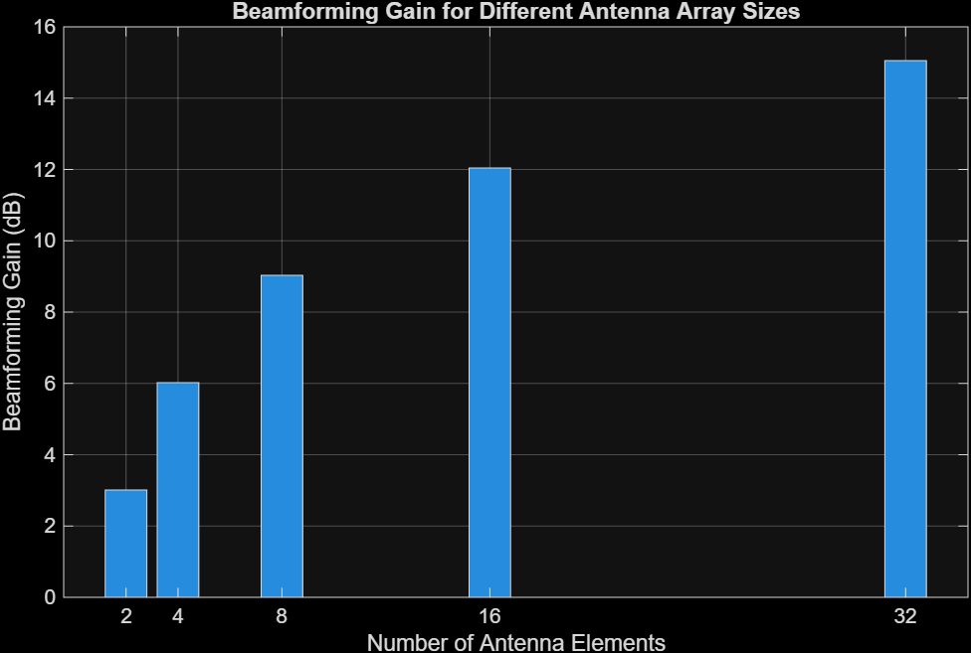
• Bar graph showing beamforming gain for different antenna array sizes.

Objective – 2
Compare Beam Width (Degrees)
Analyze the beam width corresponding to different antenna array sizes using MATLAB. Observe how increasing the number of antenna elements results in a narrower beam, thereby improving spatial resolution.

MATLAB Code:
clc;
clear;
close all;
antennas = [2 4 8 16 32]; % Number of Antenna Elements
beamwidth = [90 45 22.5 11.25 5.625]; % Beam Width (degrees)
figure
plot(antennas, beamwidth,'o-','LineWidth',2)
grid onxlabel('Number of Antenna Elements')
ylabel('Beam Width (Degrees)')
title('Beam Width for Different Antenna Array Sizes')

Expected Output
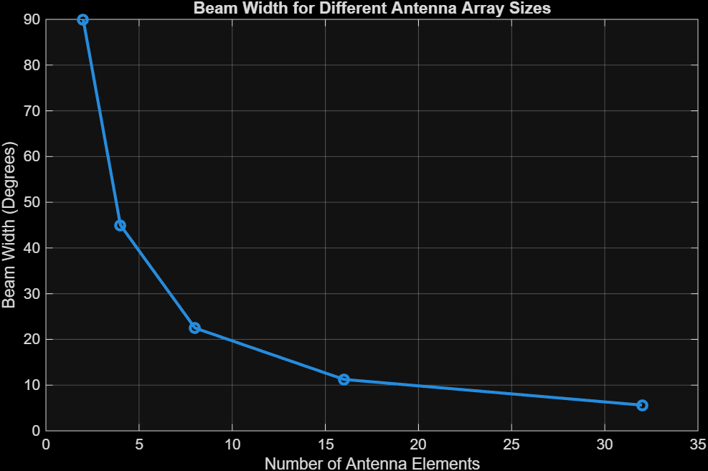
• Line graph showing beam width versus antenna array size.

Objective – 3
Analyze Main Lobe Direction (Degrees)
Simulate beam steering by varying the steering angle of the antenna array using MATLAB.
Observe the change in the main lobe direction and understand how analog beamforming directs
energy toward the intended user.

MATLAB Code:
clc;
clear;
close all;
theta = [-60 -30 0 30 60]; % Main Lobe Direction (degrees)
gain = [1 1 1 1 1]; % Constant normalized gain
figure
polarplot(deg2rad(theta), gain, 'o', 'LineWidth', 2)
title('Main Lobe Direction in Analog Beamforming')

Expected Output
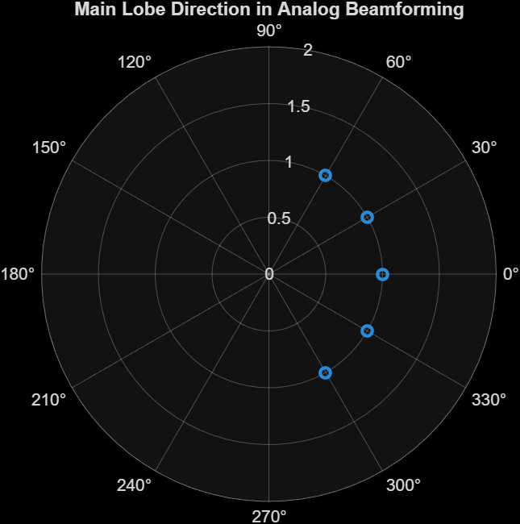
• Polar plot or beam pattern showing the main lobe steered to different angles.
Result
The MATLAB analysis successfully demonstrated the characteristics of analog beamforming. The results showed that increasing the number of antenna elements improves beamforming gain and reduces beam width, while phase adjustment enables the main lobe to be steered toward different directions.

